Project Design Phase-II
Data Flow Diagram & User Stories

Date | 26-10-26
Team ID
Project Name | HotelPro – Complete Hotel Booking and Management Solution
Maximum Marks | 4 Marks

Data Flow Diagrams:
A Data Flow Diagram (DFD) illustrates how data moves within the HotelPro – Complete Hotel Booking and Management System. It represents how users interact with the system to search for rooms, check real-time availability, and book rooms securely. It also shows how data flows between the system, the database, the administrator, and the payment gateway, including the storage and retrieval of user information, room details, booking records, check-in/check-out records, and payment information.

DFD Level 0 – HotelPro
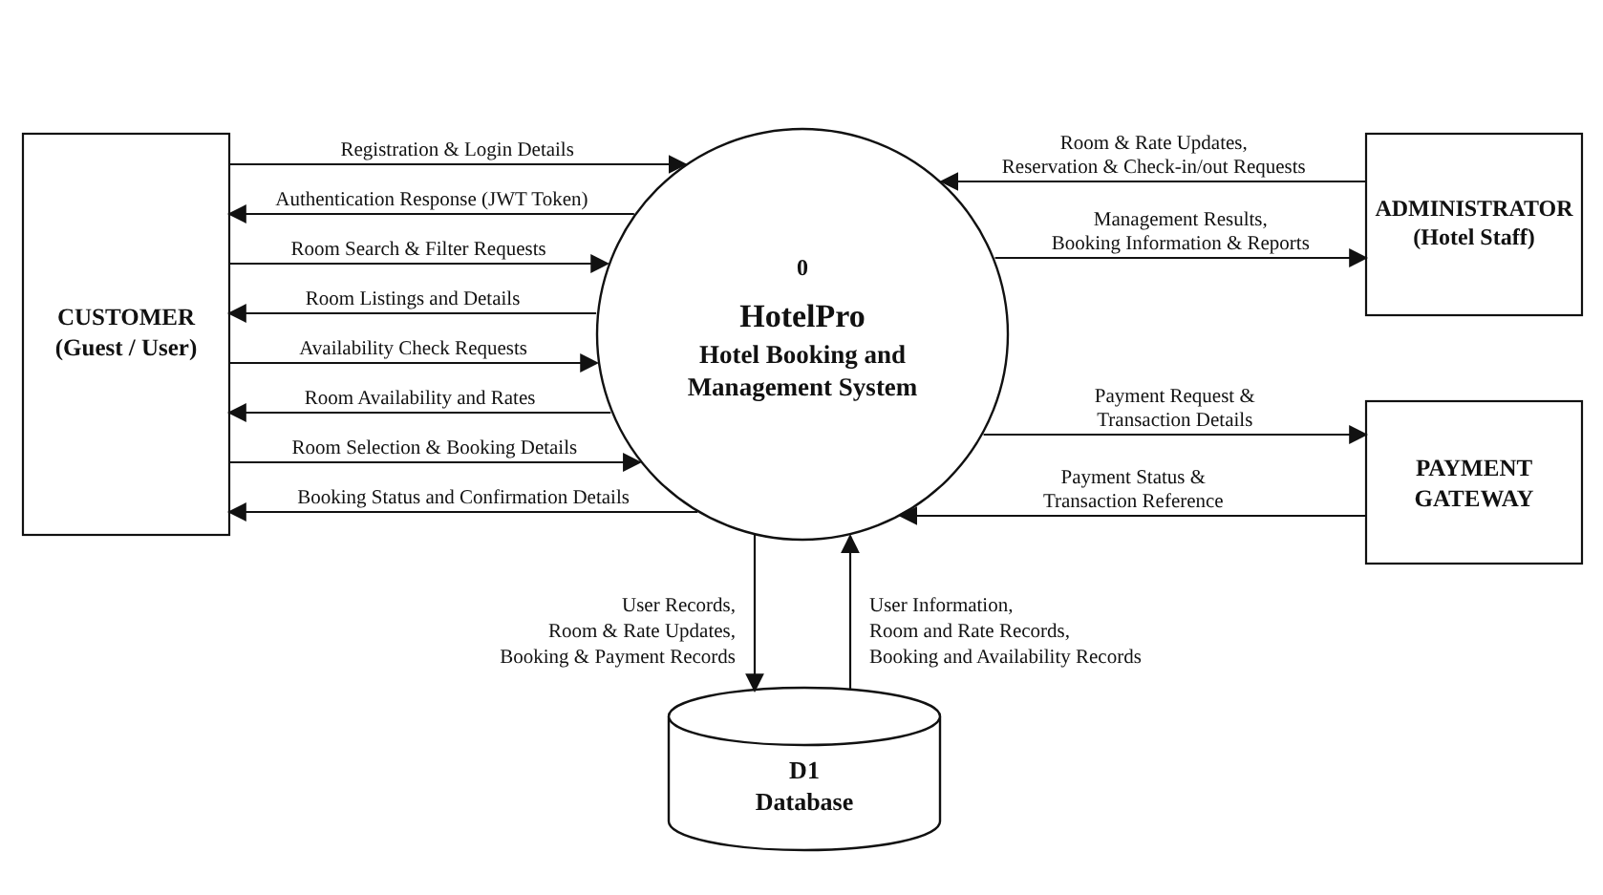

User Stories

User Story Table – HotelPro : Complete Hotel Booking and Management System
User Type | Functional Requirement (Epic) | User Story / Task | Acceptance Criteria | Priority | Release
User | User Authentication | As a user, I can register for an account and log in securely to access the HotelPro platform. | User can register with valid details and log in successfully using JWT-based authentication. | High | Sprint-1
User | Room Browsing | As a user, I can browse available rooms to explore the hotel's room types. | Available rooms are displayed with relevant details. | High | Sprint-1
User | Room Search | As a user, I can search and filter rooms by type, price, and dates to find a suitable room. | Search results display rooms matching the selected criteria. | High | Sprint-1
User | Room Details | As a user, I can view room details to learn more before booking a room. | The selected room's details, amenities, and rates are displayed correctly. | High | Sprint-1
User | Availability Tracking | As a user, I can check real-time room availability for my selected dates before booking. | The system displays accurate, up-to-date availability for the selected dates. | High | Sprint-2
User | Room Booking | As a user, I can select a room and book it for my preferred check-in and check-out dates. | The system processes the booking request and displays the booking status. | High | Sprint-2
User | Booking Confirmation | As a user, I can view my booking confirmation and reservation details after booking. | The system displays the booking status and relevant reservation details. | High | Sprint-2
User | Booking History | As a user, I can view my past and upcoming bookings and cancel a reservation if needed. | Booking history is displayed and cancellations update room availability. | Medium | Sprint-2
Administrator | Room Management | As an administrator, I can add, update, and manage rooms, room types, and rates. | Changes to room listings are saved and reflected in the system. | High | Sprint-1
Administrator | Check-in/Check-out Management | As an administrator, I can manage guest check-ins and check-outs. | Guest check-in and check-out status is updated and stored correctly. | High | Sprint-2
Administrator | Booking Management | As an administrator, I can review booking records to monitor hotel reservations. | Booking records can be retrieved and viewed correctly. | Medium | Sprint-2
System | Payment Processing | As a user, I can pay for my room booking securely through an integrated payment system. | Payment status is processed and associated with the relevant booking. | High | Sprint-2

